Approach:
The most naive method to find the length of a linked list is to count the number of nodes in the list by doing a traversal in the Linked list.
Algorithm:
- Start by initializing a pointer to the head that will be used for traversing and initializing a cnt variable to 0.
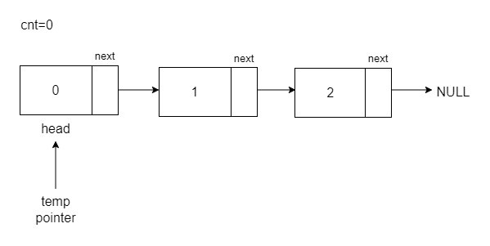
- Traverse the linked list using the pointer, and at every node, increment cnt.
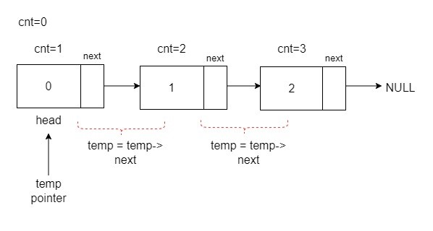
- After reaching the end of the linked list, return cnt, this will be your total number of nodes which is the length of the linked list.
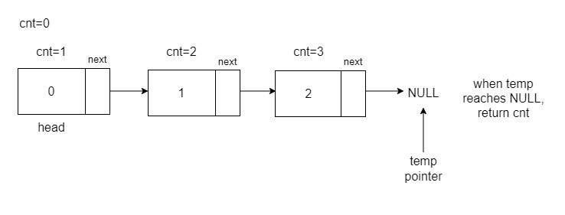
Code:
C++

class Node {
public:
int data;
Node* next;
public:
Node(int data1, Node* next1) {
data = data1;
next = next1;
}
public:
Node(int data1) {
data = data1;
next = nullptr;
}
};
// Function to calculate the length of a linked list
int lengthOfLinkedList(Node* head) {
Node* temp = head;
int cnt = 0;
// Traverse the linked list and count nodes
while (temp != NULL) {
temp = temp->next;
cnt++; // increment cnt for every node traversed
}
return cnt;
}

int main() {
vector<int> arr = {2, 5, 8, 7};

// Create a linked list
Node* head = new Node(arr[0]);
head->next = new Node(arr[1]);
head->next->next = new Node(arr[2]);
head->next->next->next = new Node(arr[3]);

// Print the length of the linked list
cout << lengthOfLinkedList(head) << '\n';
}

Java

class Node{
int data;
Node next;
Node(int data1, Node next1){
this.data=data1;
this.next=next1;
}
Node(int data1){
this.data=data1;
this.next=null;
}
};
public class LinkedList{
// Function to calculate the length of a linked list
private static int lengthofaLL(Node head){
int cnt=0;
Node temp=head;
// Traverse the linked list and count nodes
while(temp!=null){
temp = temp.next;
cnt++;// increment cnt for every node traversed
}
return cnt;
}
public static void main(String[] args) {
int[]arr={2,5,8,7};
Node head = new Node(arr[0]);
head.next= new Node(arr[1]);
head.next.next= new Node(arr[2]);
head.next.next.next= new Node(arr[3]);
// Print the length of the linked list
System.out.println(lengthofaLL(head));
}
}

